REMY

# **Description**

The Rat. Electronic. Movement. Implant is a speculative wearable electronic device that promises to enhance the user’s mobility and functioning, at the cost of their autonomy. Larger structural forces in the realm of the elites have trickle-down effects that ultimately influence the functioning of the device, and consequently, your life.

Our device was inspired by the ideas of Posthuman and Transhumanism in which people are seeking technological and scientific enhancement to become more than what is colloquially defined as “Human.” We apply this technology to the real world by understanding the realistic outcomes of Democratic Transhumanism which aims to make human enhancement accessible to all. However, in a society run by capitalism and greed, it can be assumed that Democratic transhumanism would only be achieved if there is money to be earned. If Big Pharma didn’t make 90 billion in profits with the COVID–19 vaccines, would they have worked to create it? (Haan)

Big companies and elites would seek to convince the populus to be envious of their peers who are biologically more advanced. Transhuman Artist Stelarc could be seen as an example of this as he sought to give himself genetic enhancements as he was jealous of athletes, singers, etc who could use their biological talent to get ahead. With this in mind, the elite could use these ideas to keep the poor poor by adding another consumer product that everyone *wants* to buy. A quote from Kurt Vonnegut Jr.'s Slaughterhouse-Five states that

"America is the wealthiest nation on Earth, but its people are mainly poor, and poor Americans are urged to hate themselves.”

We can expand on this quote by thinking about consumer society and how the pressures of not having the latest smartphone or gadget will put a person behind in society. Thus, the brainchip is supposed to be representative of this, not necessarily a solution but found to be another fad that everyone must get to be “cool” or “in the times.” The idea of spectacle is also important as we want to make the device futuristic looking which is a common theme for tech products that come out every year or so. The interest in technology is often energized through flashy marketing like Apple’s vision pro, which re-sparked the interest in AR/VR technology for a blazing few months.

## **How It Works**

The device will have two main parts, the brain chip and the electronic exoskeleton armature.

The brain chip will be purely performative and display light signals through RGB LEDs to simulate brain activity. This will be in the form of a small microchip, similar to the size of a desktop CPU, attached to the back of the user's head.  
  
The exoskeleton will be 3D printed air pistons attached to act as biceps. In addition, there will be TENS unit patches attached to parts of the arm to help supplement the arm action but also have the ability to spazz out the users arm when live stock market data dips in price. This control was inspired by the projects by Ka Fai Choy.

The stock market data will be simplified to positive and negative states by analyzing where the most recent ticker is red or green every second. This will be done through OpenCV, an open source computer vision repository.  
  
The electronics will be stored on the person's back with shoulder straps to support it. This area will allow for communication between the brain chip and the electronics and also communicate with the internet to grab live data.

## 

# Bibliography

"2. What is TRANSHUMANISM? Dr. Ferrando (NYU) - Course 'The Posthuman' Lesson n. 2." *YouTube*, uploaded by Posthumans, 7 Dec. 2017, [www.youtube.com/watch?v=X0m0siwI4i8](http://www.youtube.com/watch?v=X0m0siwI4i8).

"1. What Does 'POSTHUMAN' Mean? Dr. Ferrando (NYU) - Course 'The Posthuman' Lesson n. 1." *YouTube*, uploaded by Posthumans, 7 Mar. 2017, [www.youtube.com/watch?v=zi6APy0oW9A](http://www.youtube.com/watch?v=zi6APy0oW9A).​[YouTube](https://www.youtube.com/watch?pp=ygULI2lhdnNodW1hbnM%3D&v=zi6APy0oW9A&utm_source=chatgpt.com)

de Haan, Esther. "Big Pharma Raked in USD 90 Billion in Profits with COVID-19 Vaccines." *SOMO*, 27 Feb. 2023, [www.somo.nl/big-pharma-raked-in-usd-90-billion-in-profits-with-covid-19-vaccines/](http://www.somo.nl/big-pharma-raked-in-usd-90-billion-in-profits-with-covid-19-vaccines/).​

"Prospectus For A Future Body (Summary)." *Vimeo*, uploaded by KA5@RCA, 20 Sept. 2011,<https://vimeo.com/29336028>.

"electric stimulus to face -test4 ( Daito Manabe 's friends )." *YouTube*, uploaded by daitomanabe, 14 Mar. 2009,<https://www.youtube.com/watch?v=pLAma-lrJRM>.

"Transhuman Artist Stelarc | The Feed." *YouTube*, uploaded by SBS The Feed,24 Sept. 2014 ,<https://www.youtube.com/watch?v=6z_CK6Fm4_g>.​

"Rosi Braidotti: 'The Concept of Human Has Always Been Associated with Relations of Power.'" *YouTube*, uploaded by CCCB, 17 Mar. 2022,<https://www.youtube.com/watch?v=mb2_a-UX1OE>.

Psarra, Afroditi. "Ventriloquist Ontology." *Afroditi Psarra*,<https://afroditipsarra.com/work/ventriloquist-ontology>.

Vonnegut, Kurt. *Slaughterhouse-Five; or, The Children's Crusade: A Duty-Dance with Death*. Delacorte Press, 1969.

## Materials

* + TENS unit & Pads
  + 3D printed parts(Box, Arm parts, Servo Control arm, Raspberry Pi, Monitor Stand)
  + M3 & M2.5 Screws and Nuts
  + Heat Press Threads nuts
  + Acrylic Sheet
  + Circuit Board
  + Neoprene Fabric
  + Stick on Velcro Tape
  + Silver Thread
  + Red and Green Leds
  + Fabric Glove
  + Bend Sensor
  + Pressure Sensor
  + Arduino R4 Wifi
  + ESP32 Board
  + 22 gauge wire
  + Digital Potentiometer
  + On/off switch
  + Internet access point
  + Nylon Straps
  + 9v Batteries and Adapters
  + Oculus Rift Circuit Board
  + Sewing Thread

## Dimensions

## TBD

## References / Inspiration

* + *Third Hand, Extended Arm,* and *Exoskeleton* by Stelarc
  + *Ventriloquist Ontology* by Afroditi Psarra
  + *Prospectus For A Future Body* by Ka Fai Choi
  + electric stimulus to face -test4 ( Daito Manabe 's friends)

## Sketches / circuit drawings

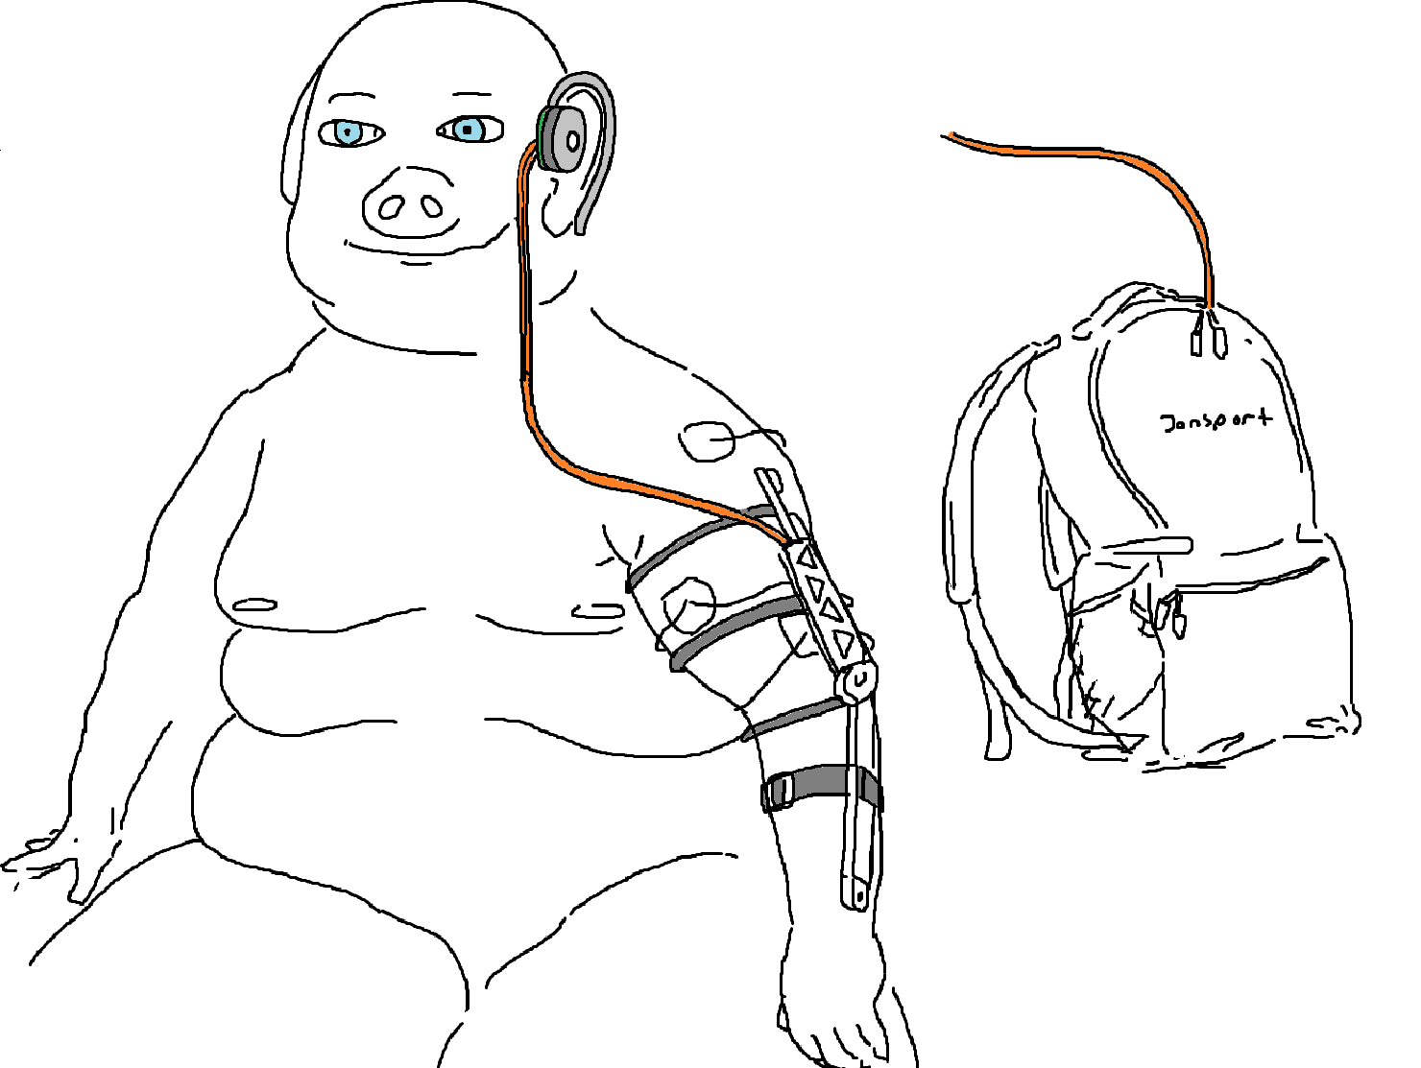

## Interaction flow chart

## Budget

* + $150